No. of Pages | 5
No. of Questions | 8

Department of Computer Science and Engineering
FINAL EXAMINATION FALL 2011

CSE320/EEE361: Data Communications
Total Marks: 90 Time Allowed: 3 Hours

- Answer Any Six (6) questions out of Eight (8) questions.
- Figure in bracket [] next to each question indicates marks for that question.

Question No. 1

  - Draw a diagram showing the relationship between TELNET, IP, TCP, VoIP, HDLC, DNS and UDP, the diagram also should show their position in the OSI model. [3 marks]
  - You write www.cricket.org in your web browser URL, but you receive a message “404 Not Found”. What is the origin of this message your DNS server or the web server? Explain. [4 marks]
  - All devices in the network that you supervise acquire their IP configuration via DHCP. Will this be a problem for the network? [3 marks]
  - Referring to the figure no. 1 below, PC0 is sending a packet to the email server, state which MAC addresses will be included in the packet (Source & Destination both and for indicating MAC addresses just mention the device ex. Web server or device interface ex. Router1 fa0/0). What if the packet is sent to the Web server? [3 marks]
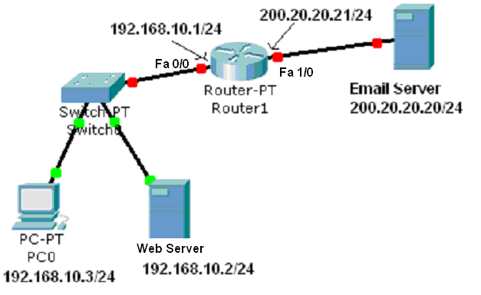
Figure No. 1
  - How does your network’s local DNS server keep track of all the URLs? [2 marks]

Question No. 2

- SMTP has a fixed port number of 25, why? [3 marks]
- TCP is connection oriented, what does it mean and how is it done in TCP? [4 marks]
- The source host sends segments starting from 501 to 2000 bytes, each segment is 500 bytes. It has received no acknowledgement from the receiver yet. It uses TCP.
  - It cannot send anymore, why?
  - How long will the sender wait?
  - All segments reach the receiver but the segment numbered 1501 is dropped due to congestion on the receiver side. How will the receiver reply? [5 marks]
- Why is UDP faster than TCP? [3 marks]

Question No. 3

Host IP address/subnetmask : 100.100.100.100/20
Network address
Broadcast address
First usable host IP address
Last usable host IP address

- Complete the above table in your script. (Please show calculations.) [8 marks]
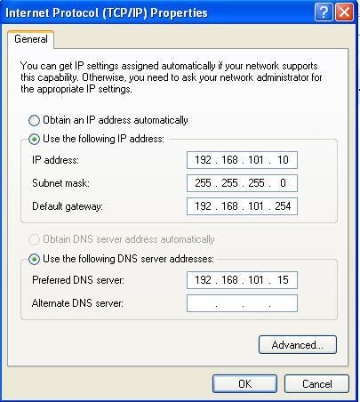
Figure No. 2
- The above figure no. 2 shows the IP configuration of a host pc. How else can we look at the IP configuration of a PC? What is the purpose of the subnet mask? [3 marks]
- Queens University and Kings College both uses the network address 192.168.10.0/24. But IP addresses should be unique to be routed to the Internet. How can the PCs of both institutions be routed to the Internet? [4 marks]

Question No. 4

- What are the advantages of using a fiber optic cable over twisted pair in a factory setting? (State at least 3 points) [3 marks]
- What are the different modes of light propagation in fiber optic cables? Draw them. [4.5 marks]
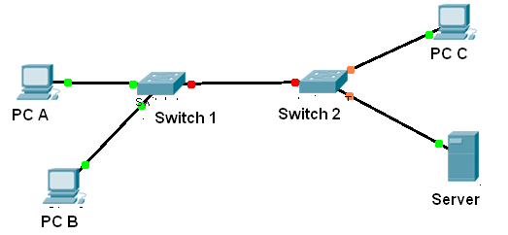
Figure No. 3
- In the above scenario shown in figure no. 3, PC B is not able to connect the Server or PC C. What are the probable media related problems? [3 marks]
- Why does a coaxial cable have lesser interference than twisted pair cable? [3 marks]
- How many pairs of wires are there in a twisted pair cable? Do we use all of the pairs? [1.5 marks]

Question No. 5

- In an IP packet, the TTL value is 124, what does it mean for the packet? [3 marks]
Gateway of last resort is 192.168.2.2 to network 0.0.0.0

C 192.168.1.0/24 is directly connected, serial 0/0
C 192.168.2.0/24 is directly connected, serial 1/0
C 192.168.3.0/24 is directly connected, FastEthernet0/0
C 192.168.4.0/24 is directly connected, FastEthernet1/0
S 192.168.6.0/24 [1/0] 192.168.3.2
S* 0.0.0.0/0 [1/0] via 192.168.2.2

Figure No. 4
- The above figure no. 4 represents the routing table of a router. What information can you figure out of the routing table regarding the router and its connections? [4 marks]
- Two packets with the destination address of 192.168.4.1/24 and 192.168.5.100/24 arrive at the router. What will the router do with the packets? [4 marks]
- What is the difference between the default gateway of a PC and default route of a router? [4 marks]

Question No. 6
0110110110111111000111110111

- The above bits represent part of HDLC data. Do bit stuffing and rewrite the data. What happens if there is a bit error in the bit stuffing done in the above data? [3.5 marks]
- What are the phases in HDLC operation and mention what kinds of frames are used in each of the phase? [3 marks]
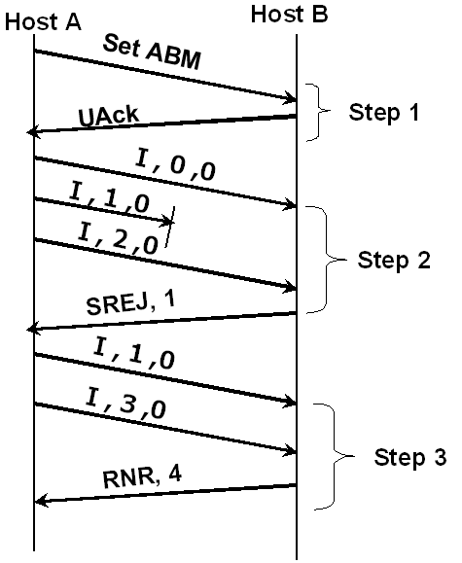
Figure no. 5

- Referring to figure no. 5 above, explain the steps shown in the HDLC data exchange process. [4.5 marks]
- Referring to same figure no. 5 above, why did host A send frame 1 and frame 3 in step 3? What will host A do after receiving the RNR frame from host B? [4 marks]

Question No. 7

- Encode the following data stream 11011000 using Differential Manchester, MLT-3 and Bi-Polar AMI encoding methods.(Separate sheet attached) [4.5 marks]
- Explain what happens when there is baseline wandering problem between the sender and receiver? How do we solve this problem? [4 marks]
- In 4B/5B block coding, 4 bits block are substituted by 5 bits blocks, why? [4 marks]
- Fast Ethernet uses 4B/5B and then MLT-3, why two encoding techniques? [2.5 marks]

Question No. 8
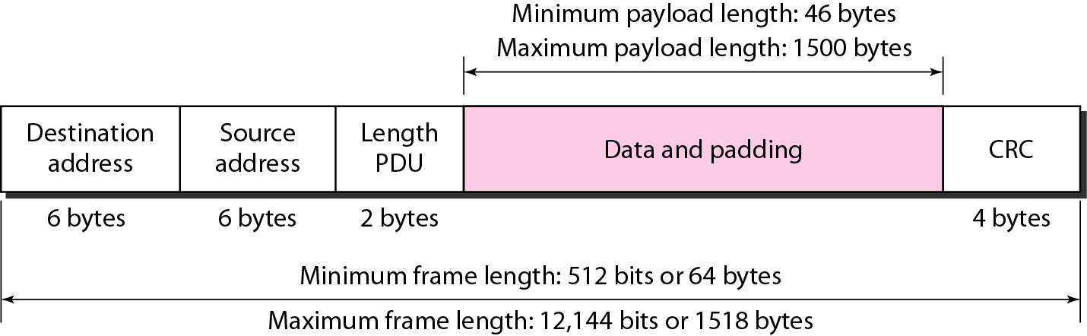
Figure no. 6

- The above figure no. 6 represents an Ethernet frame. Explain this padding that is included with the data? [3 marks]
00:20:E0:6B:17:62
00:20:E0:6B:18:79
FF:FF:FF:FF:FF:FF

- What do the above three values represent? Why are the first 6 digits same for the first two values shown? Why does the third value have all F’s? [4 marks] 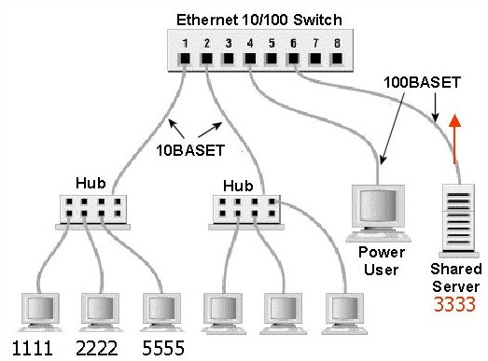
Figure no. 7

- Refer to the figure no. 7 above, the server (MAC 3333) sends a frame to host (MAC 2222). The switch has no entry in its table. What will happen next? [4 marks]
- Refer to the figure no. 7 above, what happens when host 1111 and host 5555 both starts to send frames at the same time? Explain what will happen next. [4 marks]

THE END

